**ASSIGNMENT DESCRIPTION**

Your job for this assignment is to develop an XNA game that plays a single game of War until the game ends or the player decides to quit.

I've posted a zip file that you need to complete this assignment to the Required Assessment Materials course page (ProgrammingAssignment6Materials.zip, OsxMonoGameProgrammingAssignment6Materials.zip, or LinuxMonoGameProgrammingAssignment6Materials.zip). Download and extract that file to a location of your choice.

Copy the XnaCards Help chm file onto your desktop. Double click the XnaCards Help file on the desktop to open the file.

Windows users: If you get an error message in the right-hand pane instead of documentation links, it means you’re currently blocking access to the documentation. To fix this, right-click on the XnaCards Help file on the desktop, select Properties, and select the General tab. Click the Unblock button near the lower right corner of the popup.

**REQUIREMENTS**

Here’s how your game needs to work. The game should start with two WarHand objects that you’ve filled by dealing all the cards from a Deck (the player doesn’t have to see any of that happen). The hands should be centered horizontally, with one hand near the top of the window and the other hand near the bottom of the window. You’ll also need to create two WarBattlePile objects that you place between the two War hands. You might as well create those objects now, but you’ll only be able to see them when they have cards in them.

Your display should also include a button the player can click to flip cards (starting a battle) and a button the player can click to quit the game. Here’s a screen shot of my solution:

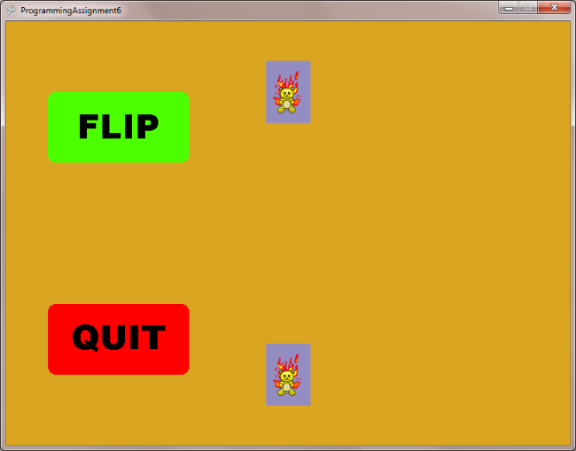

When the player clicks the flip button, you should remove a card from the Player 1 hand, flip it over, and add it to the Player 1 battle pile and do the same for Player 2. You should also make the flip button invisible and make the collect winnings button visible. In addition, you should figure out which player is the winner (the winner is the player with the highest rank card showing) and display the Winner message to the right of the Winner’s hand. Here’s a screen shot of my solution after the player has clicked the flip button:

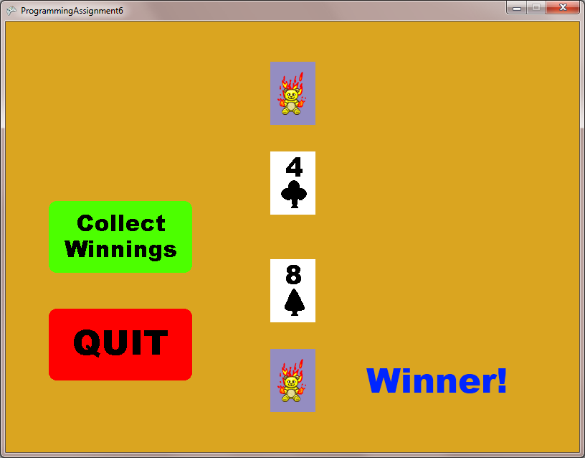

When the collect winnings button is clicked, the game should add the cards from both battle piles to the hand of the player who had the highest card, the collect winnings button should disappear and the flip button should appear. The winner message should also disappear.

In a real game of War, if the cards that are flipped are the same rank you need to have a War. This adds more complexity to the problem than I want you to tackle at this point, though, so you should handle this situation by adding Player 1’s battle pile to Player 1’s hand and Player 2’s battle pile to Player 2’s hand when the collect winnings button is clicked.

The game goes until one of the players runs out of cards or the player clicks the quit button. If one of the players runs out of cards, make it so only the quit button is visible and display the Winner message to right of the winner’s hand. The loser’s hand will disappear, which makes sense since they don’t have any cards in their hand.

**HELPFUL HINTS**

Add your functionality to the game a little bit at a time. Create, fill, and draw the WarHand objects, then test your code to make sure it works. Create and draw the menu buttons, then test your code again. Get the mouse state and update the menu buttons, then test your code again. Make the quit button actually quit the game, then test your code again. The best way to develop a game is a small piece at a time.

Be sure to shuffle the deck before dealing the cards!

The game ends when one or both of the players runs out of cards. If one of the player’s hands is empty after the collect winnings button has been clicked, the game is over so you should make the flip button invisible. You should also display the winner message next to the winning player’s hand. Note that it’s impossible for both players to run out of cards.

To test the game ending, you should only deal a few cards from the deck to each player (I just used a for loop to deal 2 cards to each player). That way you hopefully don’t have to play for a long time to get to the end of the game. You should change it back to dealing the entire deck before turning in your solution.

### Evaluation/feedback on the above work

**Note**: this section can only be filled out during the evaluation phase.

Evaluate the video for the following 7 criteria:

1. All items displayed properly with reasonable spacing and alignment
2. Menu buttons highlight properly
3. When flip cards button is clicked, cards are flipped into battle piles and correct winner message is displayed
4. During previous step, flip cards button disappears and collect winnings button appears
5. When collect winnings button is clicked, collect winnings button disappears and flip cards button appears
6. When a player runs out of cards, only the quit button is displayed
7. When a player runs out of cards, correct winner of the game message is displayed